**LTE EMM and ECM States**

**SUMMARY**

A UE can attach to a network and use services regardless of its location by exchanging control signaling messages with the network using NAS signaling between the UE and an MME. EPS Mobility Management (EMM) and EPS Session Management (ESM) functions are two major NAS functions, and this document will cover EMM states and their transitions to help understand the EMM procedures to be discussed in details in the documents to be presented later on. EMM connection management is performed through EPS Connection Management (ECM) function, and an ECM connection consists of an RRC (Radio Resource Control) connection over the radio interface and an S1 signaling connection over the S1-MME interface. Thus, ECM and RRC states will also be explained when discussing the EMM states of a UE in this document.

**Table of Contents**

  I. Introduction  
  II. EMM, ECM and RRC States   
  III. EMM State Transition  
  IV. EMM Features

  V. EMM User Information

  VI. Closing  
  References

I. Introduction

Through the previous technical documents, we have studied the LTE network architecture and LTE identifications, the fundamentals of LTE technology, and LTE security operation required for a user to attach to an LTE network and communicate securely. Now, we will look further into the detailed LTE procedures based on our previous studies.

Once a user attaches to an LTE network (or EPS system), i) the user is authenticated and registered at the network, ii) an EPS session and bearer(s) are established for using services and iii) mobility management functions for supporting the user’s movement are triggered. And at this time, it is a Mobility Management Entity (MME) in the network that takes care of all the foregoing three tasks by establishing signaling connection with the user and exchanging control messages.

Mobility and session management between a user and a network are controlled in accordance with the NAS protocols in the Non-Access Stratum (NAS) layer located in the control plane of UE and MME. The two entities communicate with each other using NAS messages. The NAS protocols are defined in 3GPP TS 24.301[1]. NAS features can roughly be classified into EPS Mobility Management (EMM) and EPS Session Management (ESM) features. Through a series of technical documents, we will describe these two procedures, EMM and ESM. This document is the first document of the series, and will provide descriptions of i) EMM state, and ii) what user information is kept in EPS entities (See “LTE Network Architecture” [2]) once an EMM procedure is initiated, to help understand the EMM procedure.

This document is organized as follows: In Chapter II, types of EMM procedures and EMM-related states (EMM/ECM/RRC) are explained. Chapter III will describe the transition among these states, and Chapter IV will summarize the characteristics of EMM in EPS entities. Finally, Chapter V will discuss what user information is kept in EPS entities in different combinations of EMM/ECM/RRC states.

II. EMM, ECM and RRC States

**2.1 Type of EMM Procedures**

Table 1 lists the types of EMM procedures supported by NAS protocols and the specific procedures belonging to each of these types. Detailed EMM procedures will be discussed through the documents to be presented later on. We will briefly see what specific procedures are in each EMM type.

**Table 1.** Types of EMM procedures

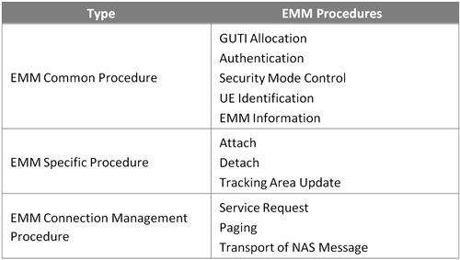

There are three types of EMM procedures as follows:

1. EMM common procedure: Refers to one that can always be initiated whilst a NAS signaling connection exists between a UE and MME. This procedure can be divided further into five procedures : globally unique temporary identifier (GUTI) allocation, authentication, identification, security mode control (SMC), and EMM information;
2. EMM specific procedure: Refers to one that is related to user mobility (registration and location update). It can be divided further into three procedures: attach, detach and TA update (TAU). In an LTE network built with an existing 3GPP network, additional procedures (i.e. combined attach, combined detach and combined tracking area update) are also included in the procedure. However, since this document discuss an LTE network only, these procedures are excluded in Table 1 (See “LTE Interworking” technical document (TBD)) for more information about the procedures); and
3. EMM connection management procedure: Refers to one related to establishing a NAS signaling connection. It can be divided further into three procedures: service request, paging and transport of NAS messages.

**2.2 EMM/ ECM/ RRC State**

EMM is a sub-layer of the NAS layer. As an EMM procedure proceeds, a UE can have one of the seven EMM states[1](http://www.netmanias.com/en/post/techdocs/5909/ecm-emm-lte-mobility/lte-emm-and-ecm-states" \l "_ftn1" \o ") and an MME can have one of the four EMM states[2](http://www.netmanias.com/en/post/techdocs/5909/ecm-emm-lte-mobility/lte-emm-and-ecm-states" \l "_ftn2" \o ") . Among these states, some states such as “EMM-Registered” and “EMM-Deregistered” are the common states that both entities can have. Hereinafter, EMM states will refer to these two states (See [1] for more information about other EMM states.).

In order for a UE and an MME exchange NAS messages with each other, a signaling connection for exchanging NAS messages must be established between them. This connection is called EPS Connection Management (ECM) connection. It is a logical connection consisting of RRC connection between a UE and an eNB, and S1 signaling connection between the eNB and an MME as seen in Figure 1. This means, when an ECM connection is established/terminated, the RRC and S1 signaling connections are all established/terminated as well. To a UE, an established ECM connection means having an RRC connection established with an eNB, and to an MME it means having an S1 signaling connection established with the eNB.

Figure 1 illustrates EMM, ECM and RRC states associated with the UE and MME.[3](http://www.netmanias.com/en/post/techdocs/5909/ecm-emm-lte-mobility/lte-emm-and-ecm-states" \l "_ftn3" \o ") EMM can be in either “EMM-Registered” or “EMM-Deregistered” state depending on whether the UE is attached to, or detached from, the network. ECM can have either “ECM-Connected” or “ECM-Idle” depending on whether a NAS signaling connection (i.e. ECM connection) is established or not. Likewise, RRC can be in either “RRC-Connected” or “RRC-Idle” depending on whether an RRC connection is established or not. Table 2 shows in what conditions a UE stays in a particular state.

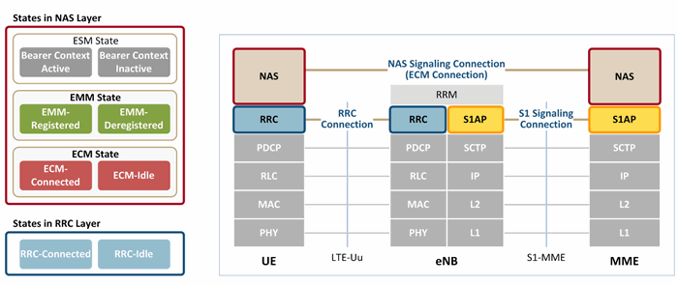

**Figure 1.**EMM, ECM and RRC states

**Table 2.** Description of EMM, ECM and RRC states

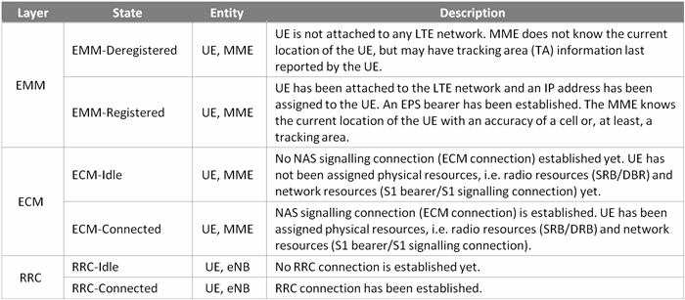

III. EMM State Transition

The states of EMM, ECM and RRC change as the EMM procedure proceeds. This state change is called “state transition”. Since RRC connection is a part of an ECM connection, ECM and RRC always have the same state in a UE’s point of view. Figure 2 shows the state transition among EMM and ECM/RRC in a UE, and the events that trigger such transition. In the Figure 2, combinations of a user’s EMM and ECM/RRC states are shown as **A**, **B**, **C** and **D**. Examples of user experiences that may result in one of such combinations are provided in Table 3.

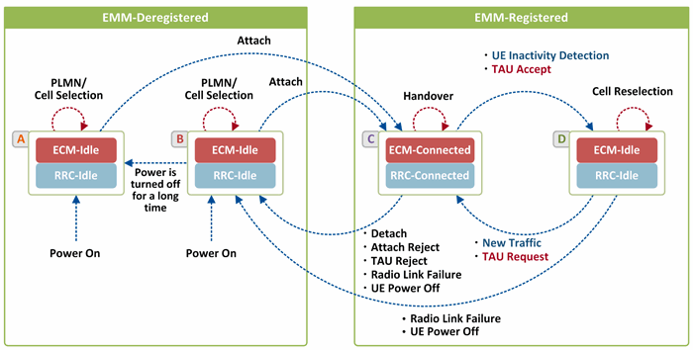

**Figure 2.** EMM State Transition

**Table 3.** User experiences in EMM, ECM and RRC states

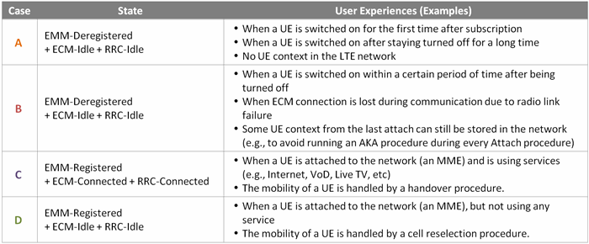

**3.1 EMM-Deregistered State**

In both **A** and **B**, the states are EMM-Deregistered, ECM-Idle and RRC-Idle, and the UE is detached from the network. However, since the UE information that the network has in two cases is different, the two cases are discussed separately. The network has no UE information other than provisioning information in case of state **A**, whereas the network keeps the GUTI and NAS Security Context (See “LTE Security” technical document) obtained last time the UE attached to it, if they are still valid in case of state **B**. So, depending on whether a UE attaches to the network in state **A** or in state **B**, the initial attach procedure may vary (For more information about initial attach procedure, see technical documents on EMM procedure that will follow).

While in state **B**, the network keeps the user information required for authentication and security setup (GUTI, NAS security context [3]) in case the UE attaches to it again. Then it deletes them after a certain period of time, and transits to state **A**[4](http://www.netmanias.com/en/post/techdocs/5909/ecm-emm-lte-mobility/lte-emm-and-ecm-states" \l "_ftn4" \o ").

While in EMM-Deregistered state (**A** or **B**), the UE figures out with which cell in which network it can communicate while selecting a Public Land Mobile Network (PLMN) and cell. When the UE requests permission to attach to the network to use services, an initial attach procedure begins, making the UE transit to state **C** (EMM-Registered, ECM-Connected and RRC-Connected).

**3.2 EMM-Registered State**

In both **C** and **D**, the states are EMM-Registered, and the UE is attached to (or registered to) the network. However, ECM and RRC can be either in ECM-Connected/RRC-Connected (**C**) or ECM-Idle/RRC-Idle (**D**) state depending on the activity status of the UE. Once the UE is successfully attached to the network by transiting its state from EMM-Deregistered state (state **A** or **B**) to state **C**, it stays in state **C** while using services, but transits to state **D** while not using services.

While in state**C**, radio and network resources are assigned to signalling connections in control plane and EPS bearers in user plane. And a UE may perform handover to a neighbor cell which turned out to have better radio signal quality than its current cell even while communicating with its serving cell. However, while in state **D**, a UE is deactivated and thus ECM/RRC connection is released. Resources are assigned neither to ECM connection in control plane, nor to EPS bearers (DRB and S1 bearer) except for S5 bearer. In this state, no user traffic (UL/DL) can be delivered by UE or the network. In order for user traffic to be delivered in state **D**, ECM connection should be established again, having the state transit to state **C**, and then a new DRB and S1 bearer should be established to activate EPS bearer. In state **D**, the UE selects a cell to camp in according to the cell reselection criteria by measuring the strength of radio signals from its serving cell and neighboring cells (See “LTE EMM Procedure: 7. Cell Reselection without TAU” technical document for more information).

State transition from **D** to **C**occurs when i) there is new traffic (UL or DL), AND ii) the UE in Idle state makes a TAU request as its TA is changed or TAU timer is expired. On the other hand, state transition from**C** to **D** occurs when i) UE inactivity is detected (there is no UE traffic (UL or DL) for a certain period of time), AND ii) the UE returns to state **D** having resources released after the UE in state **D** makes a TAU request as its TAU timer is expired (state **C**).

While in EMM-Registered state (**C**or **D**), the UE is detached from the network, transiting the state to state**B** (i.e. EMM-Deregistered state) if it is turned off or if the radio link fails (if the packet error rate over the radio link exceeds the threshold value. In addition, state transition from EMM-Registered to EMM-Deregistered (state **B**) occurs when the UE in state **C**performs handover to a non-LTE network, when its request to attach to the network is rejected (Attach Reject), or its TA update request is rejected (TAU Reject).

IV. EMM Features

In this chapter, we will describe what kind of EMM procedure-related features are supported by EPS entities in each of the states defined in Figure 2. Below, we will discuss the following topics one at a time: i) at which granularity the UE’s location information is known by each EPS entity and in each state, ii) in which states EPS bearer and NAS signalling connection are established, iii) features relating to UE’s mobility in each state, and iv) what types of UE IDs are set in each EPS entity and in each state.

**4.1 UE Location Information**

Table 4 shows the granularity of UE location information recognized by each EPS entity. EMM-Registered state (**C** and **D**) indicates that a UE is attached to a network and the network knows the UE’s current location. In this state, the network knows the location of the UE at the granularity of cells if the UE is in active state (**C**), and at the granularity of TAs if in idle state (**D**). To an HSS, unlike other EPS entities, a UE’s location is also known at MME level except while the UE is in state **A**.

**Table 4.** UE location information set in each EPS entity

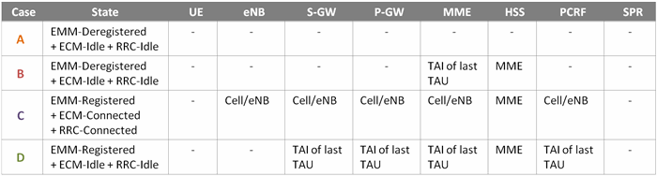

**4.2 EPS Bearer and NAS Signaling Connection**

Table 5 shows in which state an EPS bearer for delivering user traffic and a NAS signaling connection for delivering NAS signaling messages are established and maintained. Once a UE successfully attaches to a network and becomes EMM-Registered state, it uses services provided through EPS bearers. An EPS bearer consists of three bearers: Data Radio Bearer (DRB), S1 bearer and S5 bearer. As seen in Figure 3, all these three bearers are established and stay activated (and thus radio and network resources are assigned) in ECM-Connected/RRC-Connected state (state **C**) where user traffic is being delivered On the other hand, only S5 bearer is established and stays activated and other bearers are deactivated (any assigned resources are released) in ECM-Idle/RRC-Idle state (state **D**) where there is no user traffic.

NAS signalling connection (i.e. ECM connection), consisting of RRC connection and S1 signalling connection, is established only when user traffic is being delivered, i.e. in ECM-Connected/RRC-Connected state (state**C**). When the user is detached from the network (state **A** or **B**), or is attached to the network but in idle state (state **D**), ECM connection is released.

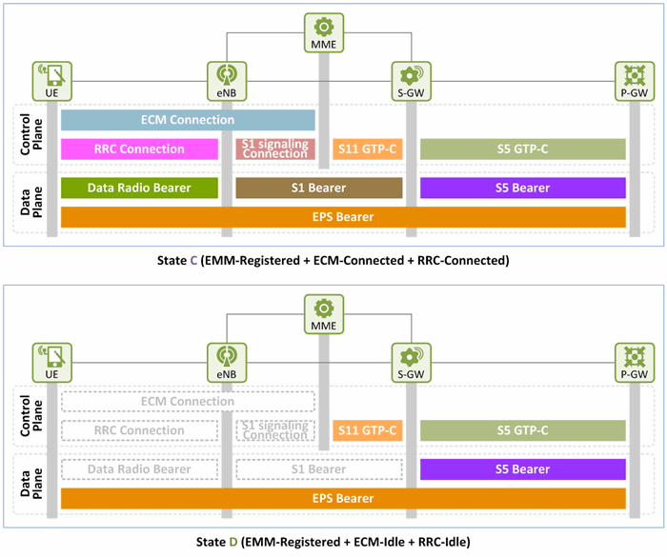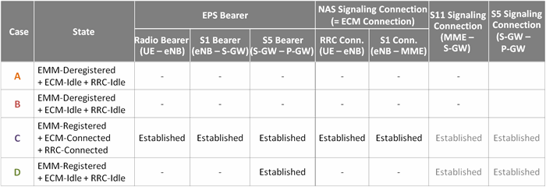**Table 5.** EPS bearer and NAS signaling connection information

**Figure 3.** EPS bearer and signaling connections in EMM-Registered state

**4.3 Mobility**

Table 6 lists features relating to a UE’s mobility in each state.

**Mobility**: A turned-on UE in EMM-Deregistered state (state **A** or **B**) figures out in which cell and in which network it is located by selecting a PLMN and cell. A UE using services in EMM-Registered state (state **C**) performs handover from its current cell to another neighbor cell which turned out to have better radio signal quality than its current cell. A UE currently not using services, but in EMM-Registered state (state **D**) performs cell reselection searching for another neighbor cell with better radio signal quality than its current cell, and camps in one with the best quality.

**Tracking Area Update**: A UE in EMM-Registered state (state **C** or **D**), whether using services or not, updates its TA whenever it is changed. However, while in ECM-Idle/RRC-Idle state (state **D**), the UE updates its TA on a regular basis every time the TAU timer is expired even when its TA is not changed. TA update is initiated by a **TAU Request** message sent by the UE.

While the UE is in ECM-Idle/RRC-Idle state (state **D**), ECM/RRC connection should be established first, and the state must be transited to ECM-Connected/RRC-Connected state (state **C**) in order for the UE to update its TA. Once the UE in state **C** sends**TAU Request** message and receives **TAU Accept** message from an MME, the TAU procedure is completed. Then, ECM/RRC connection is released, and the UE turns back to ECM-Idle/RRC-Idle state (state **D**).

**Paging**: When a UE is attached to the network, but in idle state (state **D**), if there is user traffic to deliver, the network initiates paging to wake up the UE, consequently transiting the UE’s state to state **C**. The paging is conducted based on the Tracking Area Identifier (TAI) information provided by the UE during its last TA update.

**Table 6.** Features related to user mobility

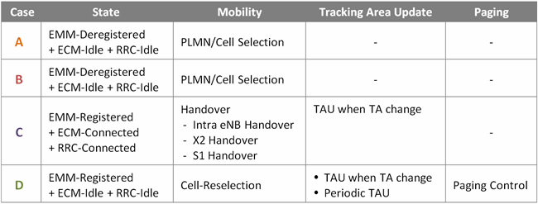

**4.4 UE IDs**

Table 7 is the list of UE IDs that each EPS entity can have in each of four states (See “LTE Identification I” technical document for more information about UE IDs). A UE IP address is assigned by a P-GW when the UE initially attaches to the network, causing a default bearer to be established, and is released when the default bearer is deactivated. GUTI is assigned by an MME when a UE’s initial attach to the network is completed successfully and is used instead of International Mobile Subscriber Identity (IMSI), a permanent ID. If the UE is detached from the network successfully, the UE and the MME keep the UE’s last GUTI and use it as a UE ID next time the UE attaches to the network, even after detached. C-RNTI is assigned by an eNB to distinguish UEs in a cell in RRC-Connected state (state **C**), and is valid only in the cell associated with the assigned C-RNTI. eNB UE S1AP ID and MME UE S1AP ID are used by an eNB and MME to distinguish UEs over S1-MME interface. And, Old eNB UE X2AP ID and New eNB UE X2AP ID are used by a serving eNB and target eNB to distinguish UEs over X2 interface when a UE performs handover from the source eNB to the target eNB.

**Table 7.** UE IDs set in each EPS entity

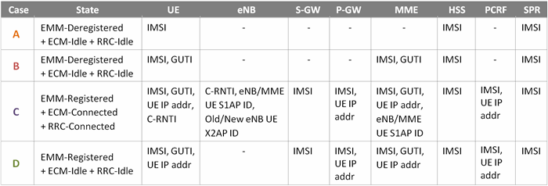

V. EMM User Information

This chapter will describe the data that each EPS entity has in relation to a user in EMM/ECM/RRC states defined in Figure 2. The description will be given in order of **A** → **B** → **C** → **D**.

**5.1 EMM-Deregistered + ECM-Idle + RRC-Idle**

Table 8 is the list of user information that EPS entities have in state **A**. In state **A**, a network has no user information other than those provisioned by its operator. That is, all the information in a UE and NE are provisioned values in this state. IMSI and LTE K, the master key, are required for user authentication while Default APN, EPS QoS Subscribed Profile and Access Profile are needed for establishing an EPS session and default EPS bearer. In the EPS QoS Subscribed Profile and Access Profile are included the following information:

* **EPS QoS Subscribed Profile (in HSS)**: QCI, ARP, APN-AMBR and UE-AMBR
* **Access Profile (in SPR)**: SDF filter, QCI, ARP, APN-AMBR, UE-AMBR and Charging Methods (e.g. offline)

**Table 8.**User information set in state A

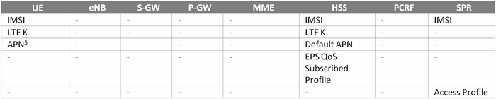

**5.2 EMM-Deregistered + ECM-Idle + RRC-Idle**

Table 9 is the list of user information that EPS entities have in state **B**. In state **B**, the information used last time a UE attached to the network is kept valid in the UE and the network (MME and HSS), and so the UE can use the same during its next attach. Such information includes the GUTI last assigned by the MME, the TA information updated during the UE’s last TA update, NAS security contexts last used between the UE and MME, UE-AMBR assigned by the MME to the UE, etc. The user information that the UE and NE did not have in state**A**, but do in state **B** are marked in blue, and the ones already provisioned in state **A** are shown in black in Table 9.

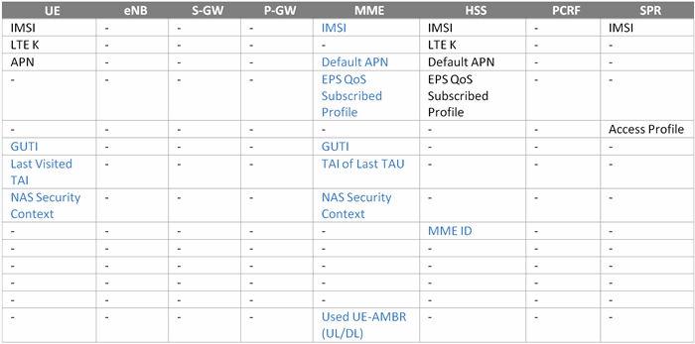**Table 9.** User information set in state B

**5.3 EMM-Registered + ECM-Connected + RRC-Connected**

Table 10 is the list of all user information that EPS entities have in state **C**. In state **C**, an EPS bearer and NAS signalling connection are all established, handover and TA updates are performed. So, all the user information required for such purposes are all set in this state. For easier comparison with state **B**, user information newly added to the UE and NE in state **C** is marked in blue, and those same as in state **B**, but with different values are marked in green.

**Table 10.** User information set in state C

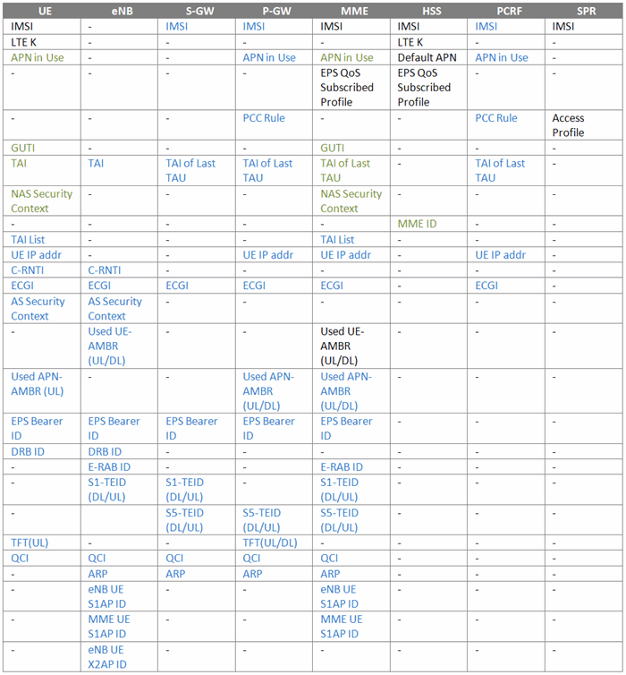

**5.4 EMM-Registered + ECM-Idle + RRC-Idle**

Table 11 is the list of user information that EPS entities have in state **D.** This state can be reached only after transition from state **A** or **B** to state **C** first. In state **D**, all the resources that have been assigned while in state **C** to the EPS bearer (DRB and S1 bearer) and NAS signalling connection, except for S5 bearer, are released. The information to be released is marked in gray in Table 11. In the S1 bearer, downlink resources (S1-TEID (DL)) are released, whereas uplink resources (S1-TEID (UL)) assigned by a S-GW are kept (See those marked in blue in Table 11). So, on the next transition to state **C**, if any, the same uplink resources (S1-TEID (UL)) can be used again when establishing S1 bearer. We can see all the resources are released between the UE and eNB once the UE turns idle as in state **D**.

**Table 11.** User information set in state D

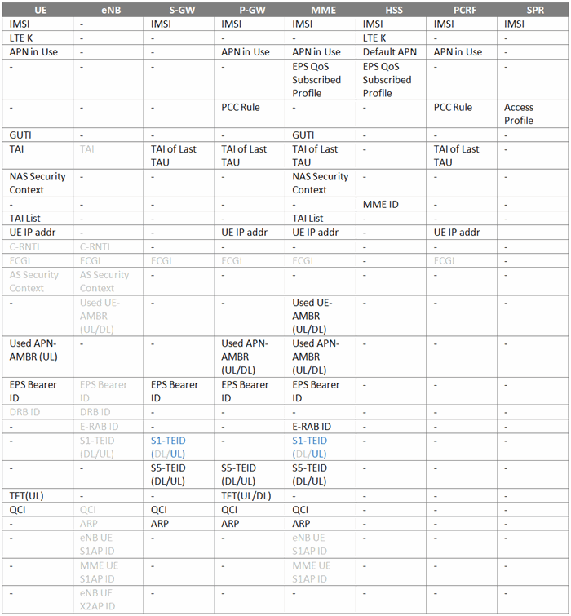

VI. Closing

We have learned EMM, ECM and RRC states and their transition processes before we move on to EMM procedure. It would make more sense to discuss topics relating to EPS session/bearer establishment when covering ESM procedure. However, since the initial attach procedure, a part of EMM procedure, includes establishment of a default EPS bearer, ESM-related procedures required to explain the EMM procedure were covered in this document. Based on our understanding of the EMM, ECM and RRC states discussed so far, we will further study the EMM procedures through the documents to be presented later on.

References

[1] 3GPP TS 24.301, “Non-Access-Stratum (NAS) protocol for Evolved Packet System (EPS); Stage 3”.

[2] Netmanias Technical Document, “[LTE Network Architecture: Basic](http://www.netmanias.com/en/?m=view&id=techdocs&no=5904)”, July 2013.

[3] Netmanias Technical Document, “[LTE Security II: NAS and AS Security](http://www.netmanias.com/en/?m=view&id=techdocs&no=5903)”, August 2013.

[4] NMC Consulting Group Confidential Internal Report, “E2E LTE Network Design”, August 2010.

Footnotes

[1](http://www.netmanias.com/en/post/techdocs/5909/ecm-emm-lte-mobility/lte-emm-and-ecm-states" \l "_ftnref1" \o ") EMM-Null, EMM-Deregistered, EMM-Deregistered-Initiated, EMM-Registered, EMM-Registered-Initiated, EMM-TAU-Initiated, and EMM-Service-Request-Initiated

[2](http://www.netmanias.com/en/post/techdocs/5909/ecm-emm-lte-mobility/lte-emm-and-ecm-states" \l "_ftnref2" \o ") EMM-Deregistered, EMM-Deregistered-Initiated, EMM-Registered, and EMM-Common-Procedure-Initiated

[3](http://www.netmanias.com/en/post/techdocs/5909/ecm-emm-lte-mobility/lte-emm-and-ecm-states" \l "_ftnref3" \o ") ESM state, one of the NAS states, is out of the scope of this document and will not be covered herein.

[4](http://www.netmanias.com/en/post/techdocs/5909/ecm-emm-lte-mobility/lte-emm-and-ecm-states" \l "_ftnref4" \o ") Transition time from state **B** to state **A** and whether to delete information or not may vary depending on vendors’ implementation.

[5](http://www.netmanias.com/en/post/techdocs/5909/ecm-emm-lte-mobility/lte-emm-and-ecm-states" \l "_ftnref5" \o ") A UE may or may not have an APN.

There is an error in Figure 2 and it will be fixed later.

Find comments belows ([from Jakub Bluszcz in LinkedIn](https://www.linkedin.com/grp/post/1180727-5999388656165548036#commentID_discussion%3A5999388656165548036%3Agroup%3A1180727)):

RLF doesn’t necessarily result in transition from RRC-CONNECTED to RRC-IDLE [3GPP 36.331 5.3.11].

If cell selection and reestablishment procedures are successful the UE remains in RRC-CONNECTED. In case there is no suitable cell or reestablishment fails the UE goes to RRC-IDLE.

Some selected cases are presented here: <http://www.sploty.com/en/rlf-and-connection-reestablishment>

Moreover, the RLF and subsequent transition to RRC-IDLE doesn’t result in transition from EMM-REGISTERED to EMM-DEREGISTERED. The correct state should be EMM-REGISTERED substate NO-CELL-AVAILABLE [see 24.301 5.1.3.2.4.7], which means that after new cell selection followed by new RRC Connection Establishment the EMM Service Request procedure can be successful (i.e. no Attach nor default EPS bearer establishment is necessary).